**Html5**

**HEAD section(meta):**

* This section describes about the webpage.

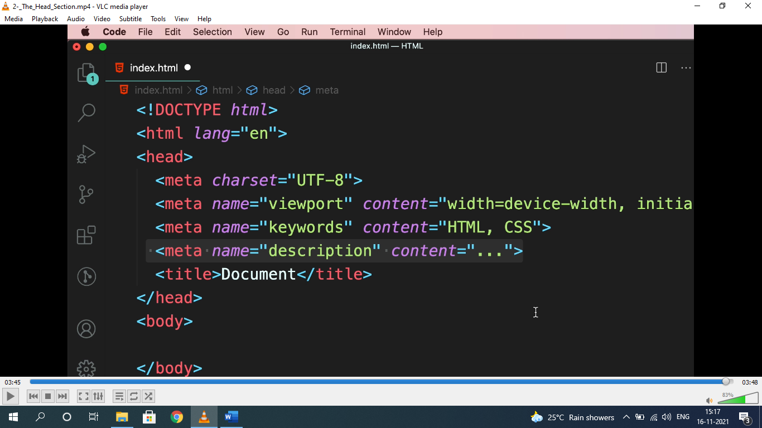ading

* Viewport=display size of device. Used to display content properly.

**<h1..h6>, <strong>, <em>:**

* Heading should be used in hierarchy.

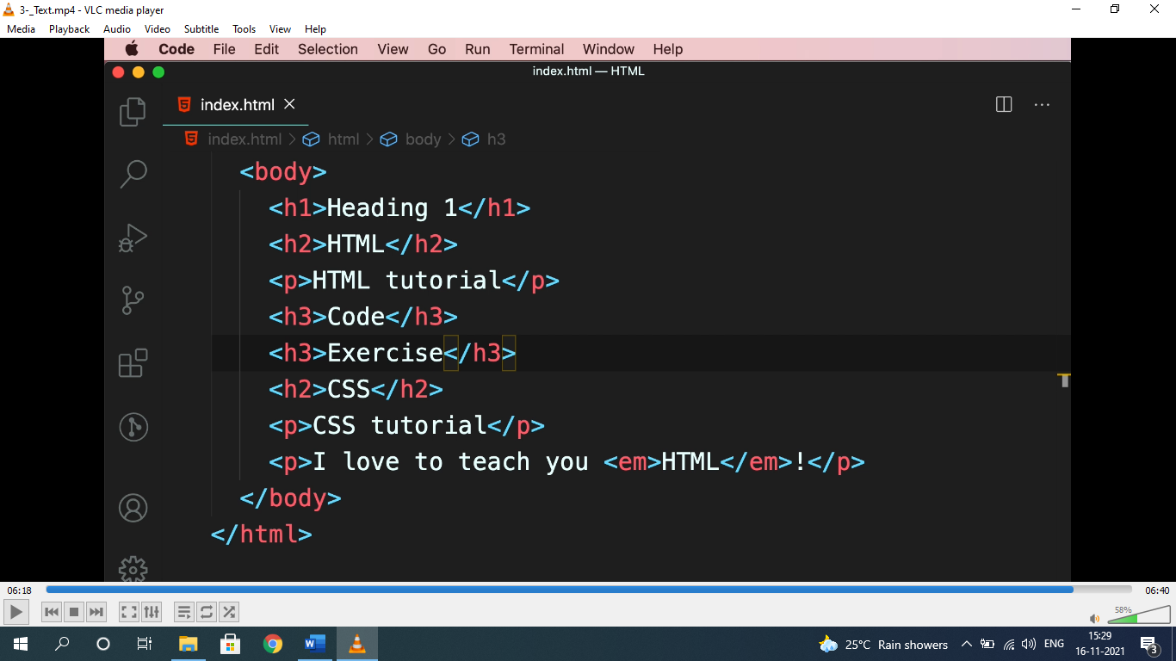

* <em> used for emphasizing and <strong> used for highlight.

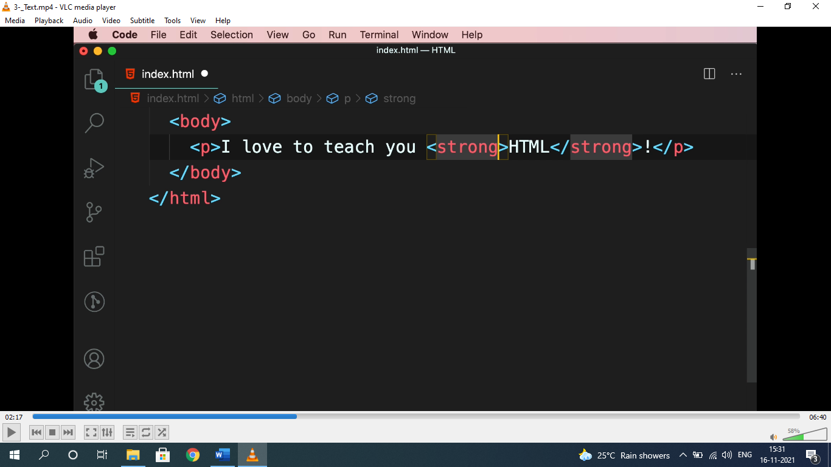

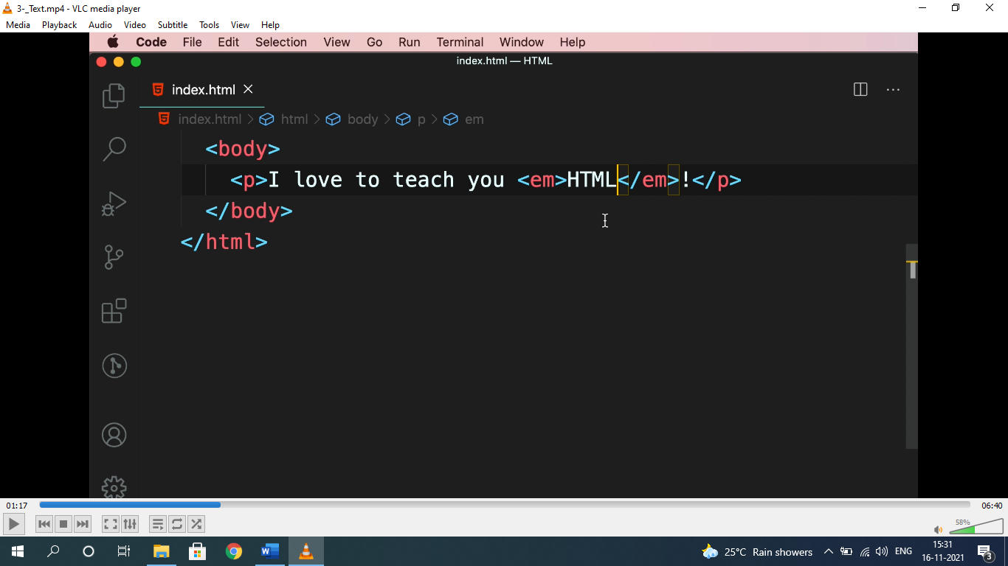

**ENTITIES(&;):**

* To represent elements, symbols as it is, it should be written within HTML entities i.e “&…;”.

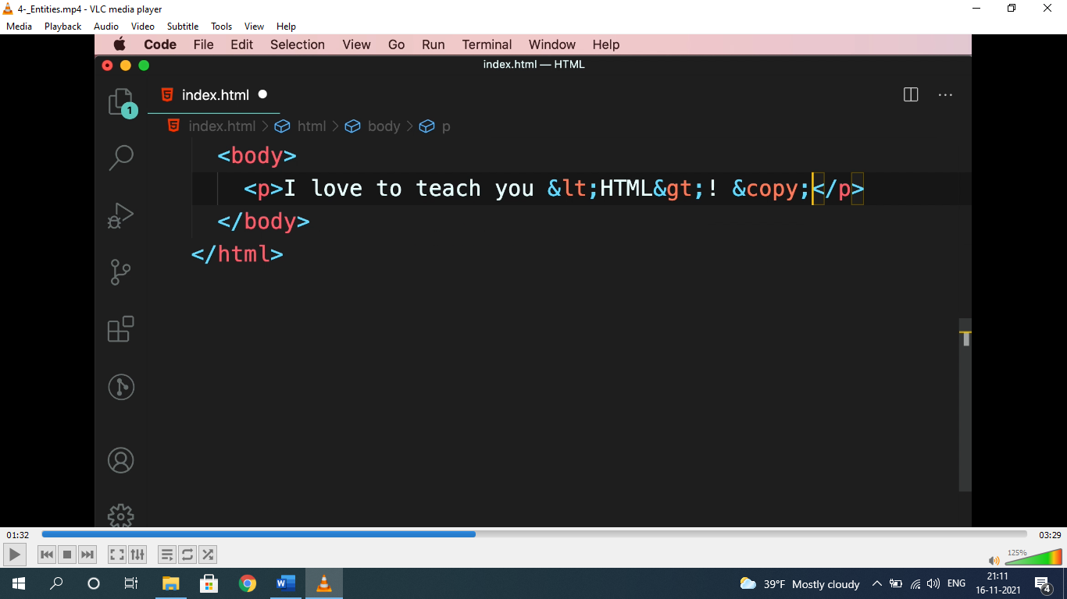

* For entities: ***search html entities in google.***

**HYPERLINK(href):-**

* used to navigate to links, images, download, pages etc.

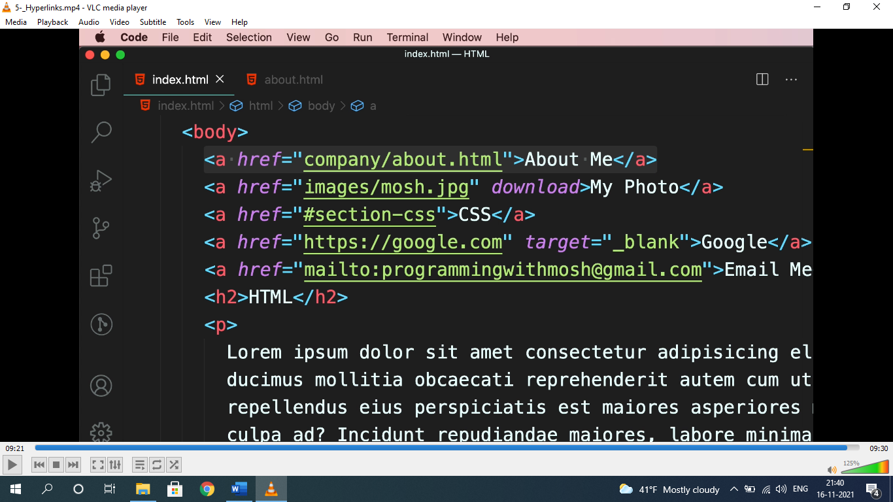

* “about me” is to navigate a page, “my photo” is to navigate to a photo with “download” attribute to download, CSS is to navigate to a ID “#section-css”. Google is to navigate to google home page.
* “**go to top**” can be done by assigning ID to “#”.

**IMAGES:**

* setting image height and width without cropping or compressing “object-fit: cover” property is used.

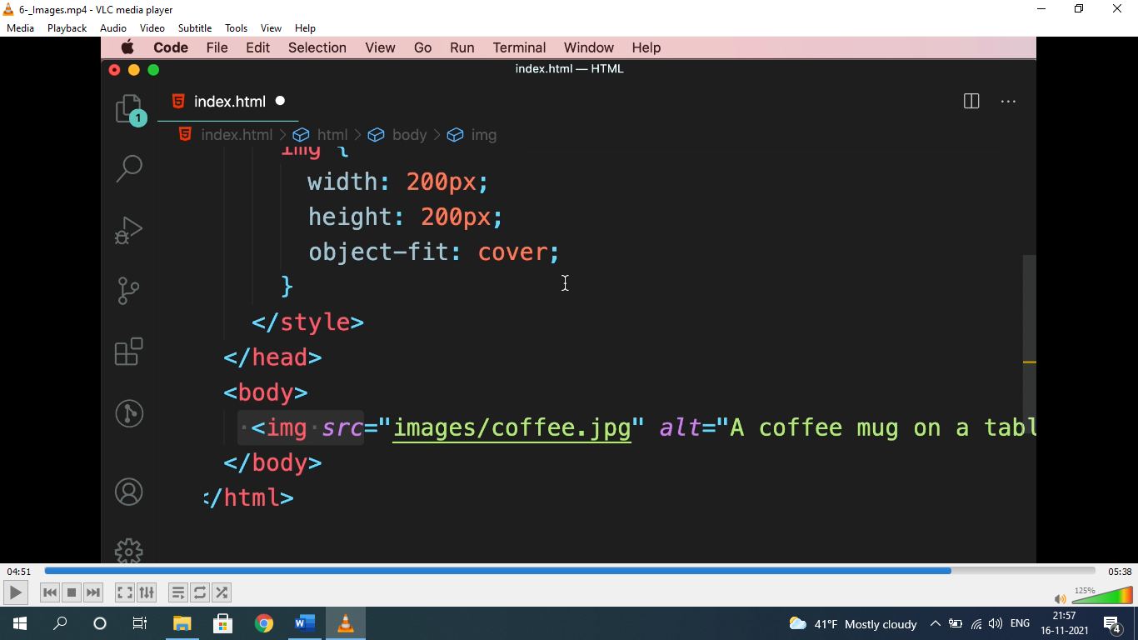

* for free images: ***unsplash.com***

**<video> & <audio>:**

* used to show video and audio.

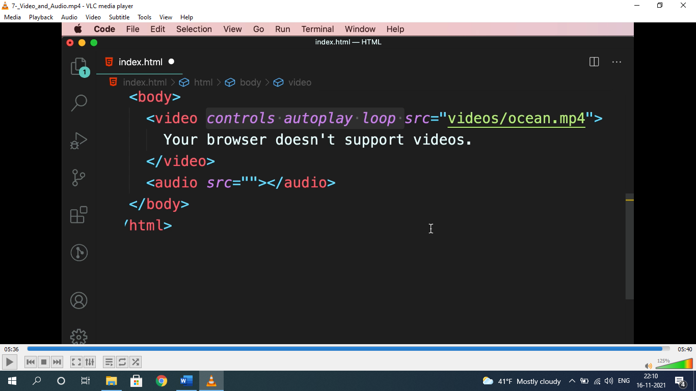

* “your browser doesn’t support videos” will only render when browser doesn’t support video.
* Attribute for video and audio are same.
* For free audio and videos: ***pexels.com***

**LISTS (<ul>, <ol>, <dl>);**

* Used to represent list, nav items etc.

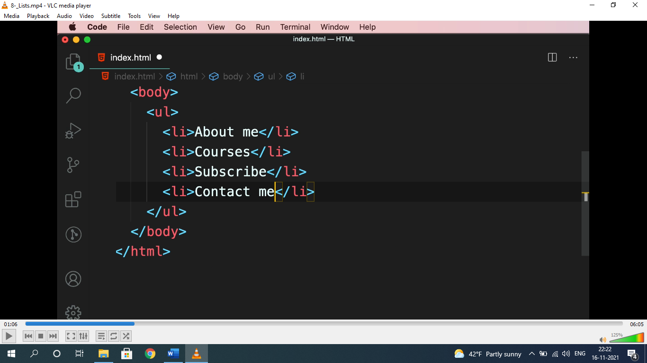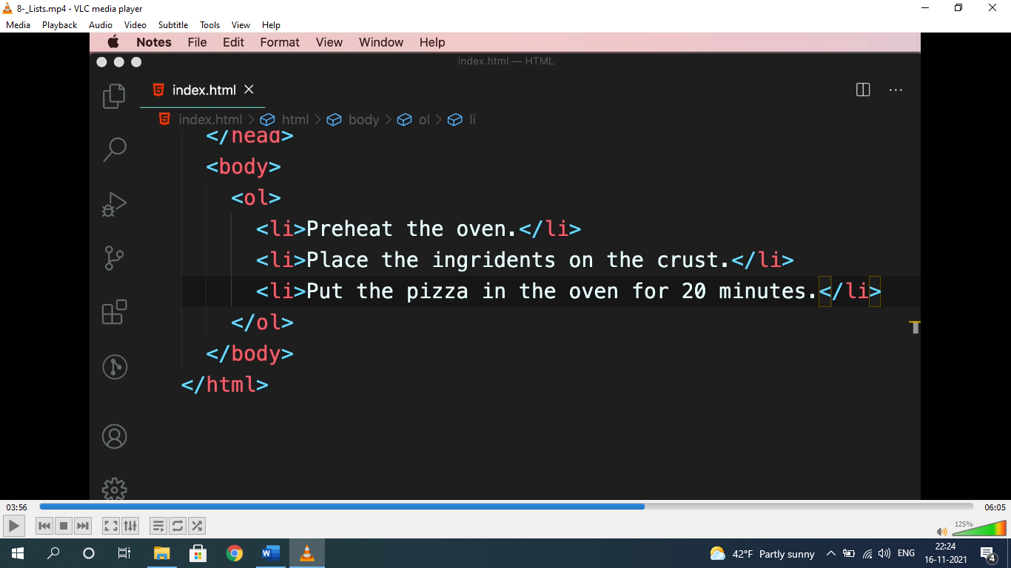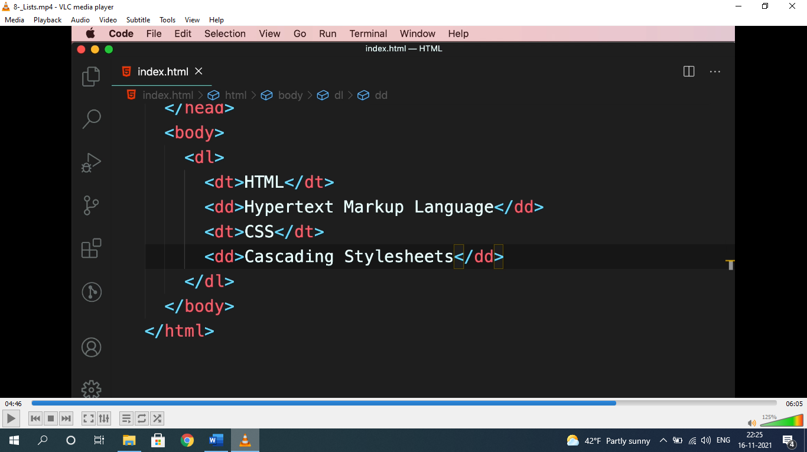

* dl= description list, dt= description term, dd= description details.

**TABLES:-**

* used to represent data in tabular format.

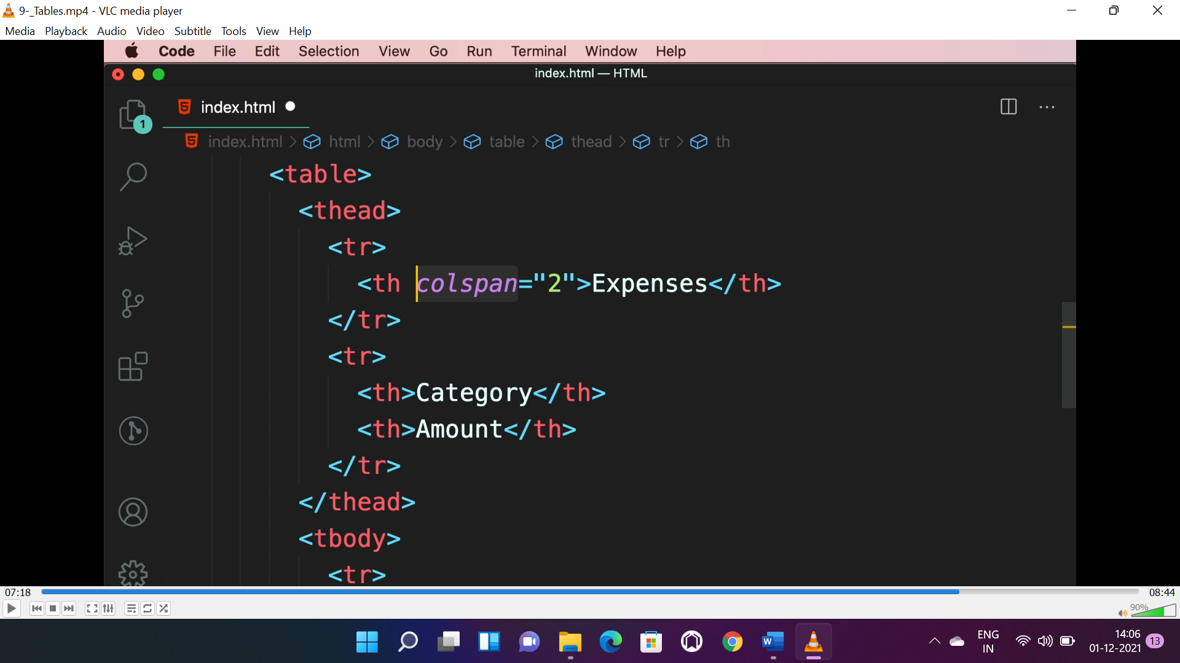

* **<thead> -** for table header, **<tbody> -** for table body, **<tfoot> -** for table footer.
* **Colspan –** no. of cols to be collapsed, **rowspan –** no. of rows to be collapsed.

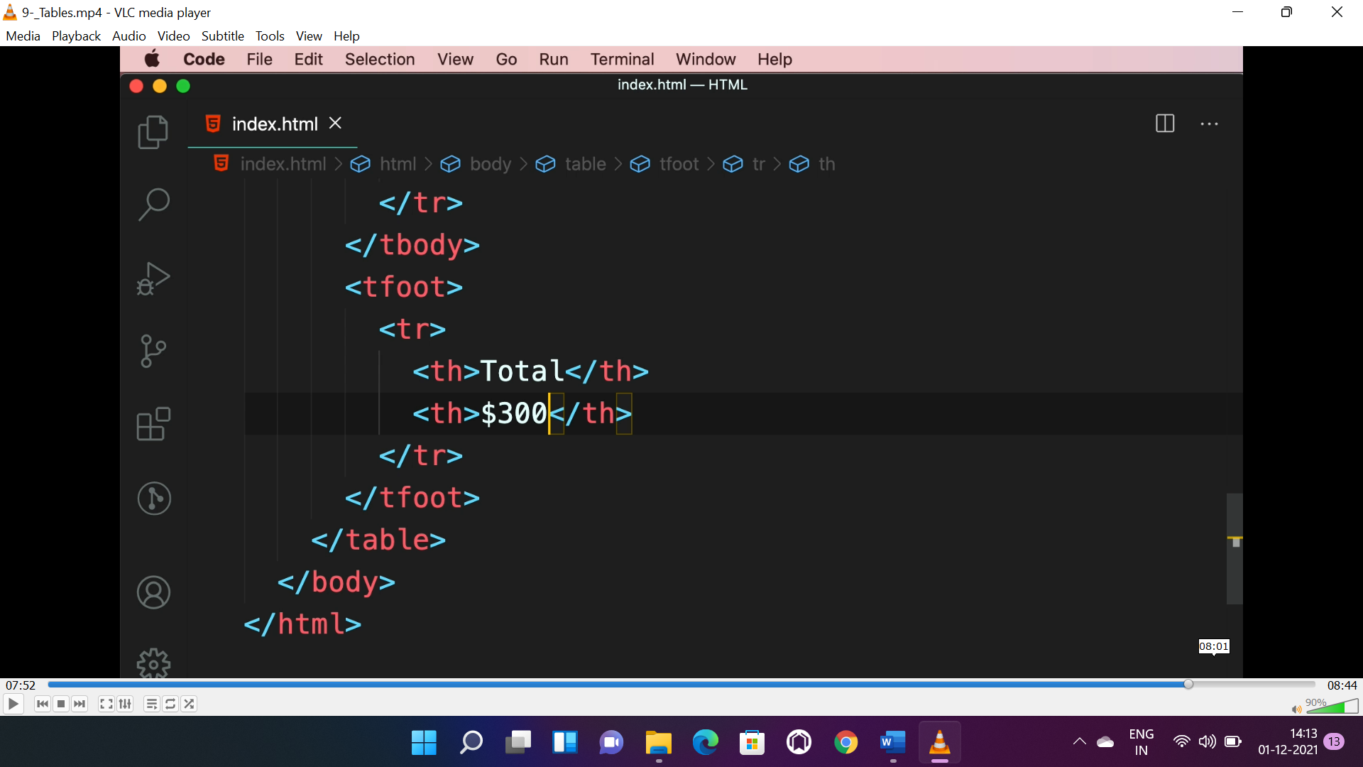

**CONTAINERS(<div>, <span>):**

* <div> is block level element, will cover full screen width, <span> is inline element will cover required width.

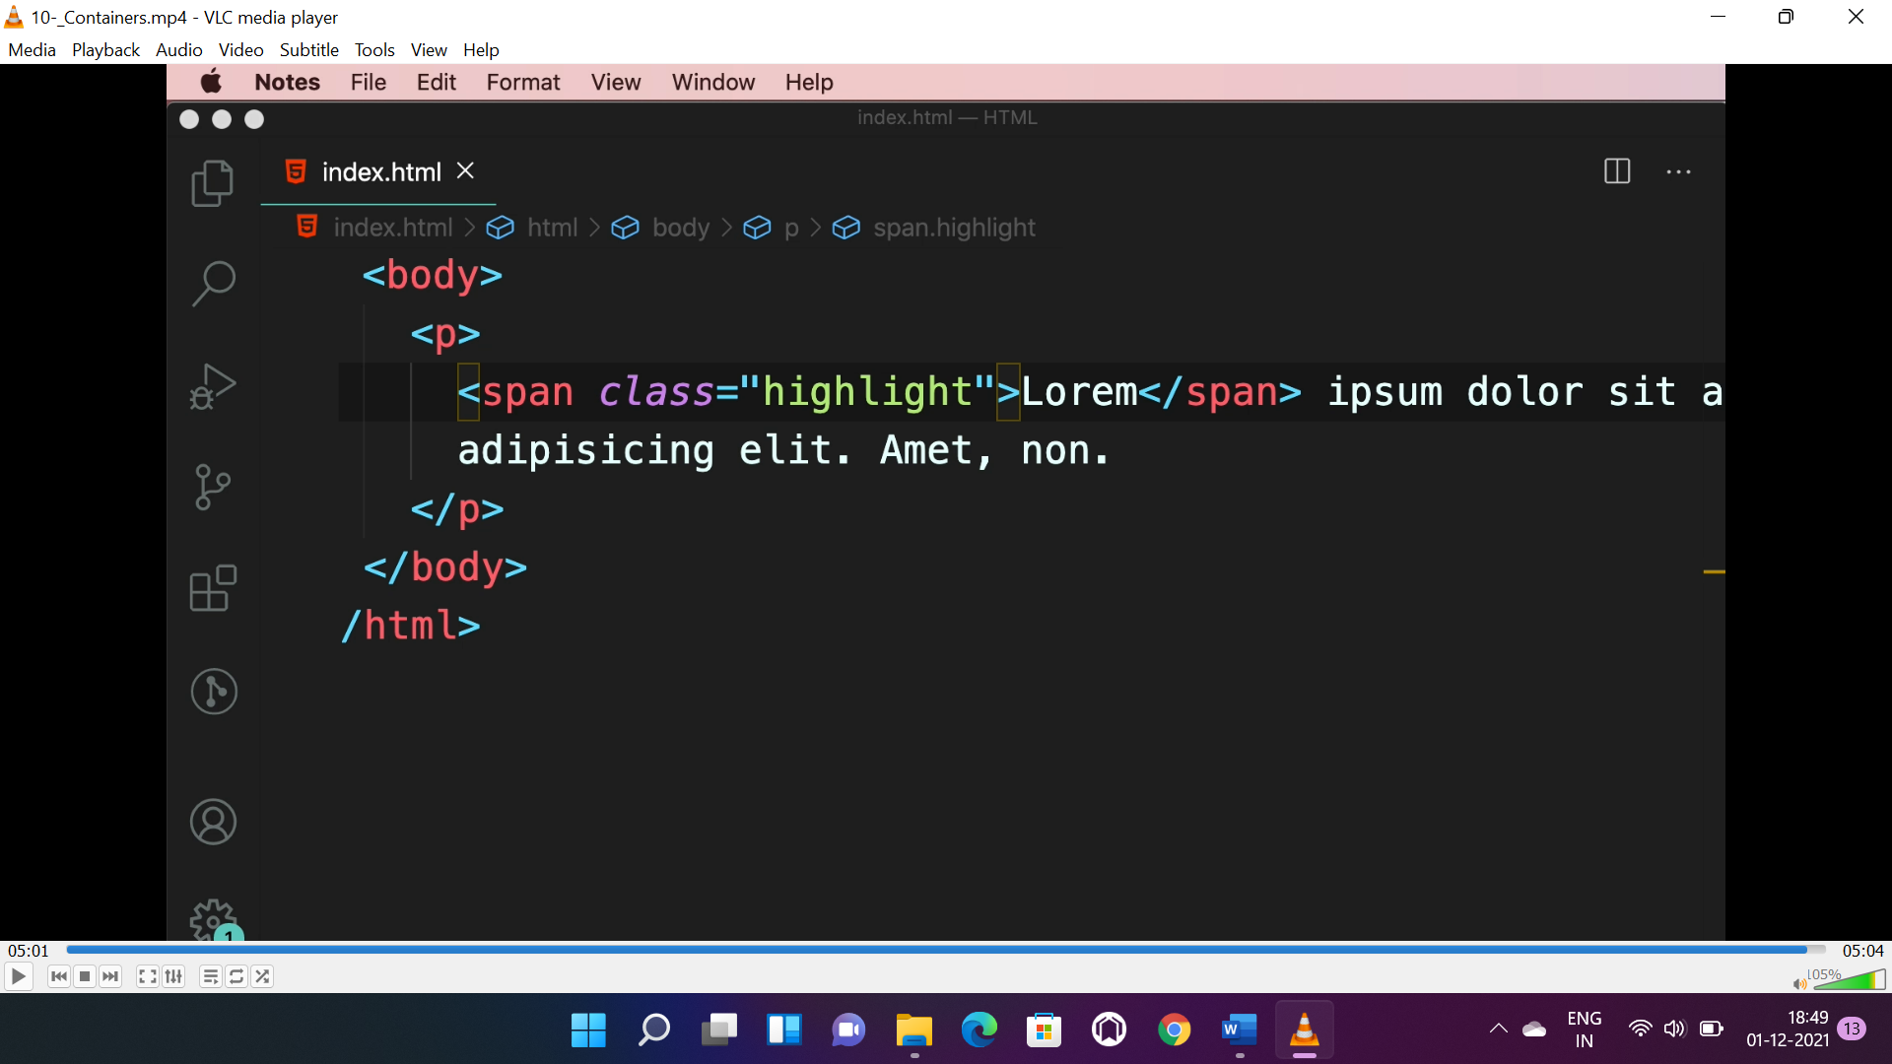

**HTML-5-CONTAINERS:**

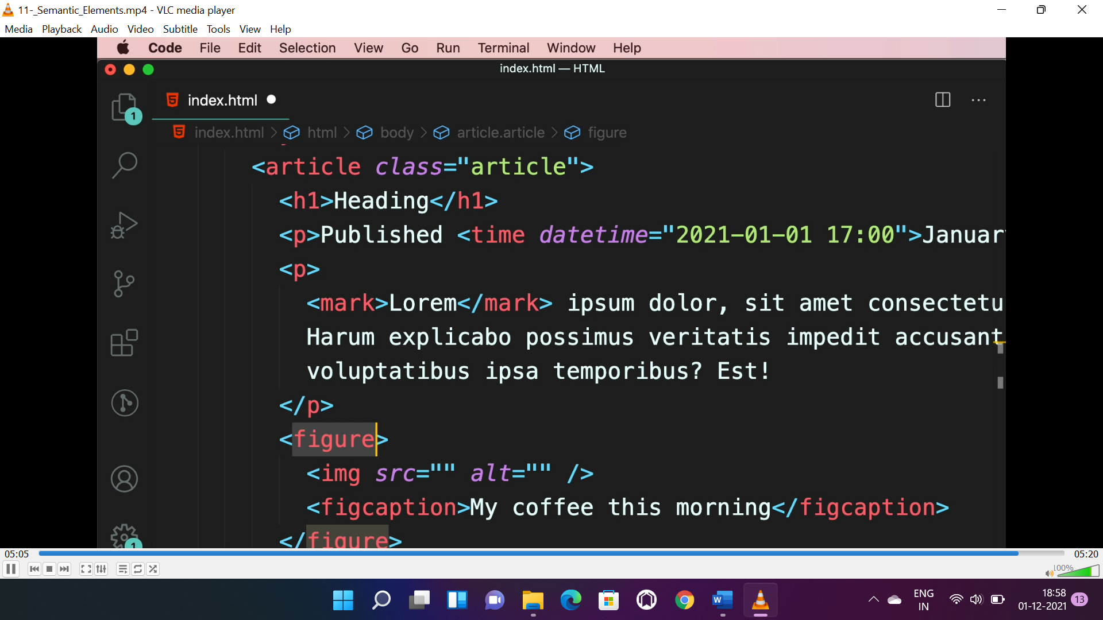

* <article> - for articles(more meaningful, easy for search engines to search)
* <time> - for representing time.
* <mark> - for highlighting text.
* <figure> - for images.
* <figcaption> - for defining details of that images.

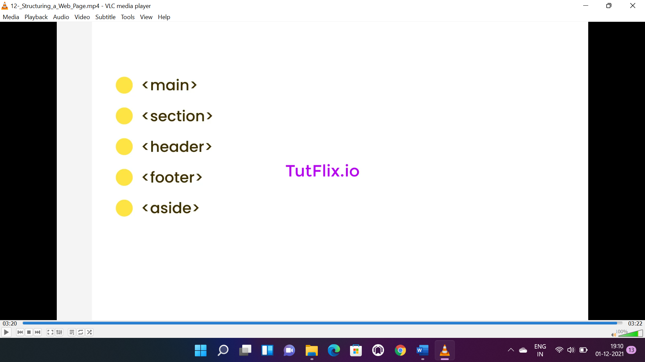

* <main> - is the main content of page and can be used only once.
* <section> - used for group of related elements.
* <header> - used for navigation bars.
* <footer> - for footer of the page.
* <aside> - for side bar and content related to main element.

**CSS**

**BASIC SELECTORS:**

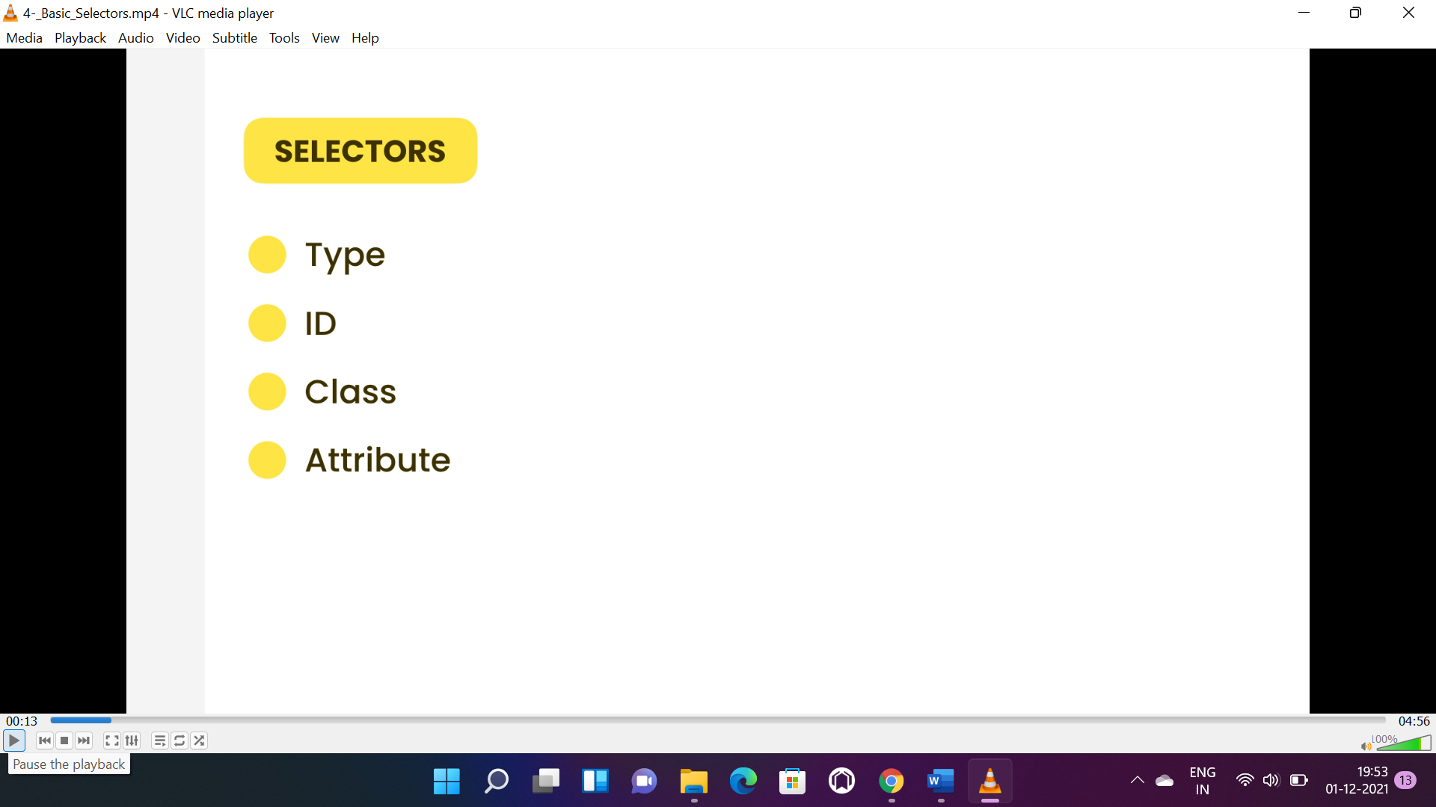

* Type selector is <div>, <span>, <h1>, <p>.
* Id selector is #id_name.
* Class selector is .class_name.
* Attribute selector is href, src etc.

**RELATIONAL SELECTORS(>, +, ~):**

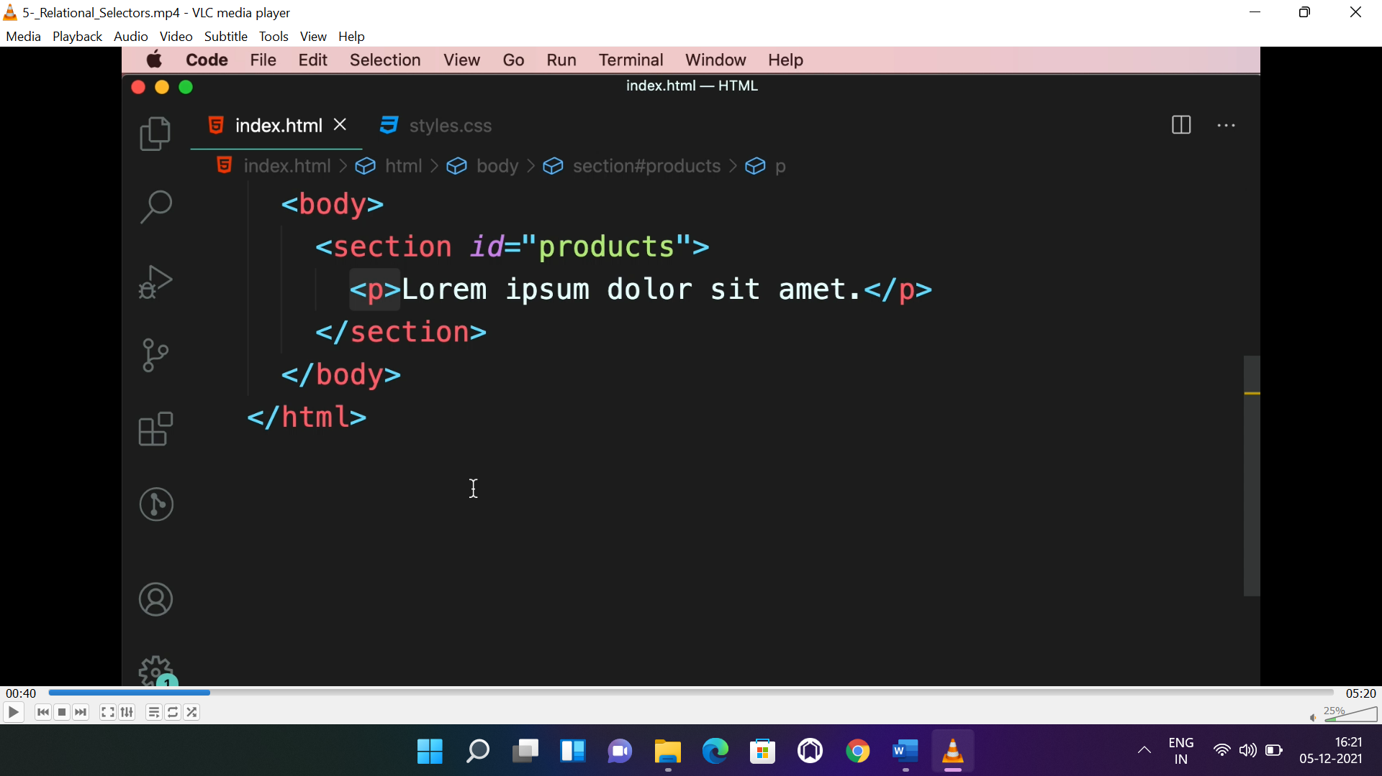

* To select all paragraph inside <section>, the selectors will be like:

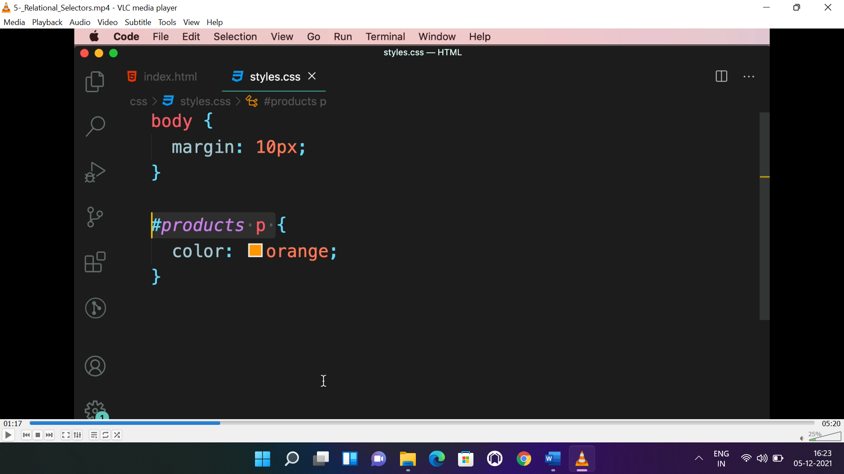

* To select 1st paragraph inside <section>, the selectors will be like:

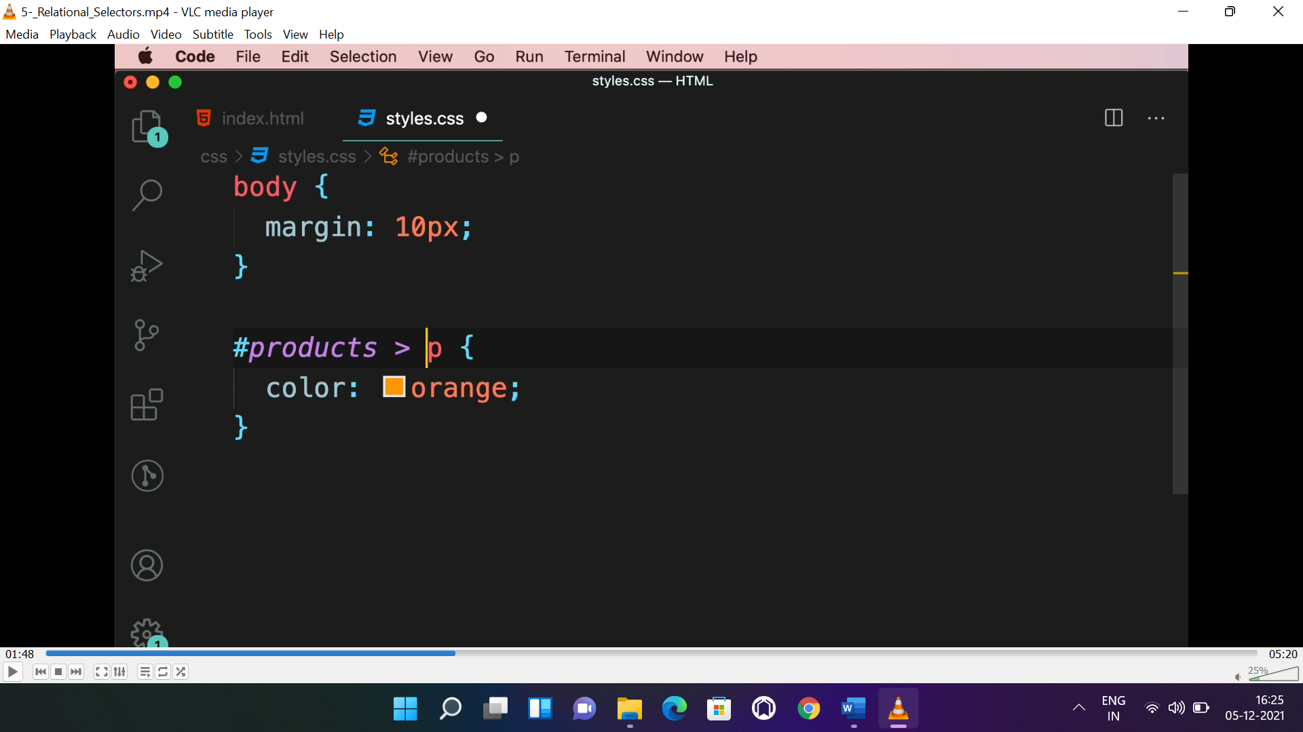

* To select the para right after the <section>, the selector will be like:

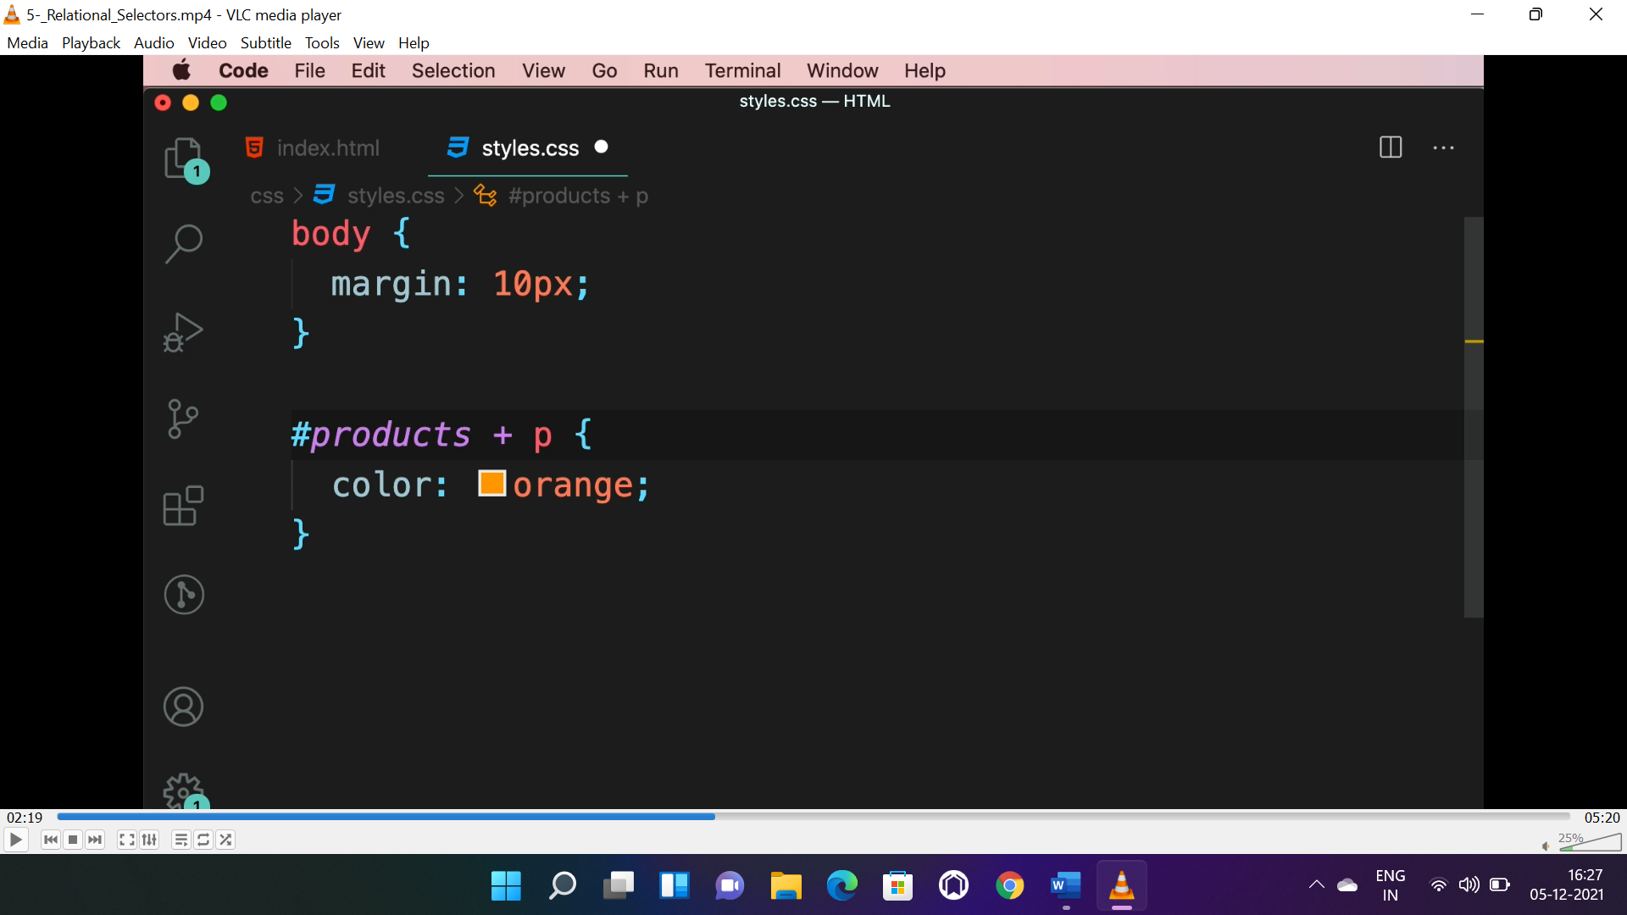

* To select all para right after the <section>, the selector will be like:

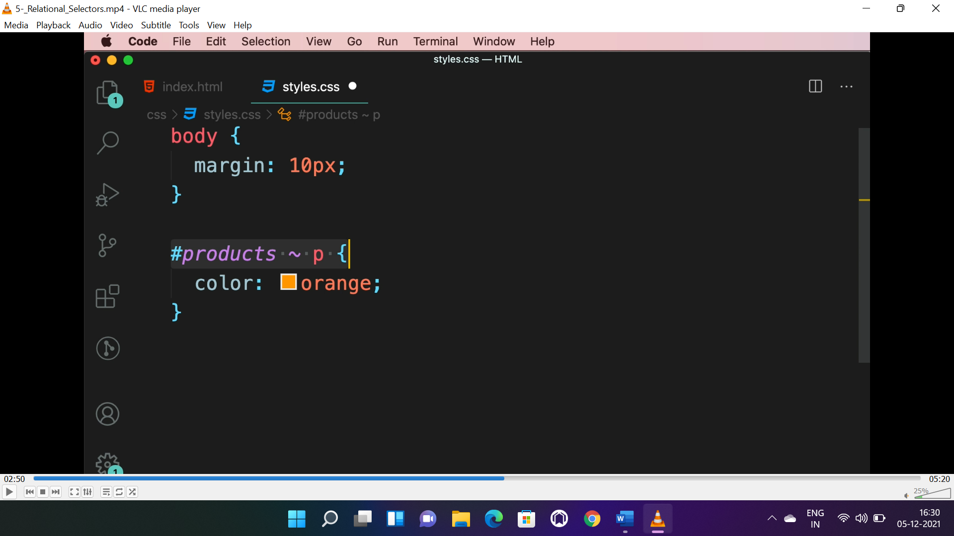

**PSEUDO CLASS:**

* These classes are applied automatically by the browser, not needed to define.
* **Ex:-:first-child, :first-of-type, :last-child, :last-of-type, :hover, :focus, :visited etc..**

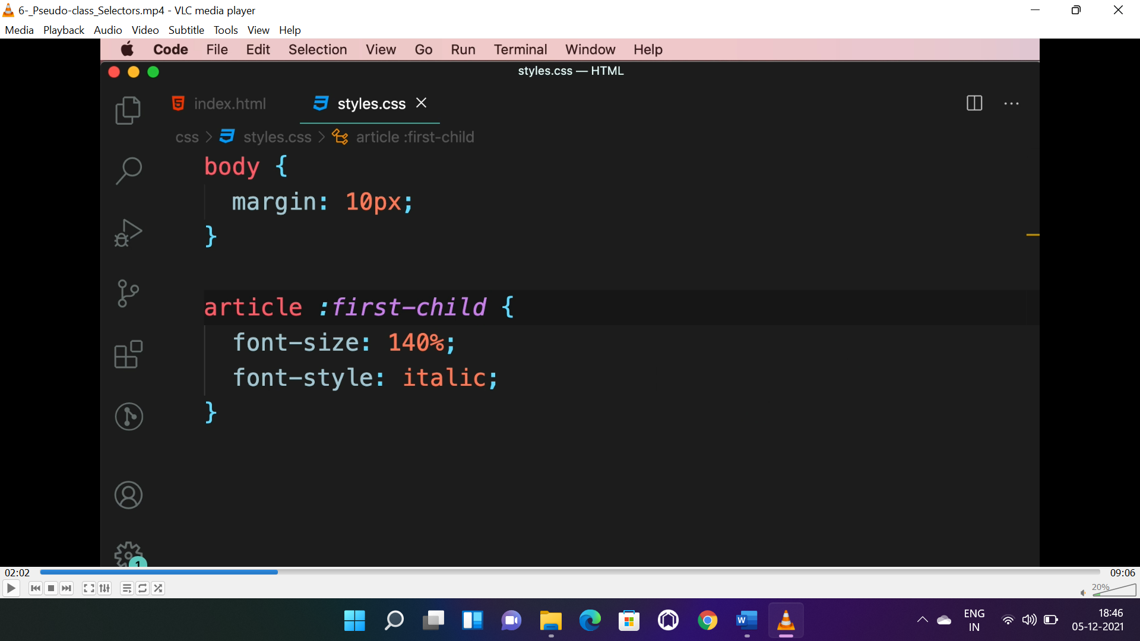

* It will apply to the 1st child element.

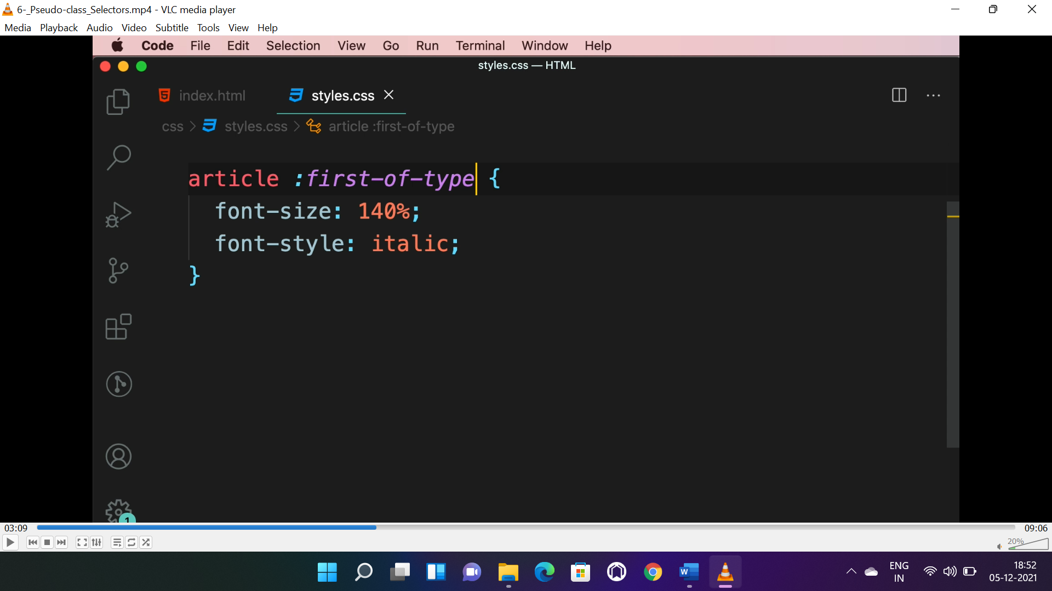

* It will apply to the 1st element of all type element.

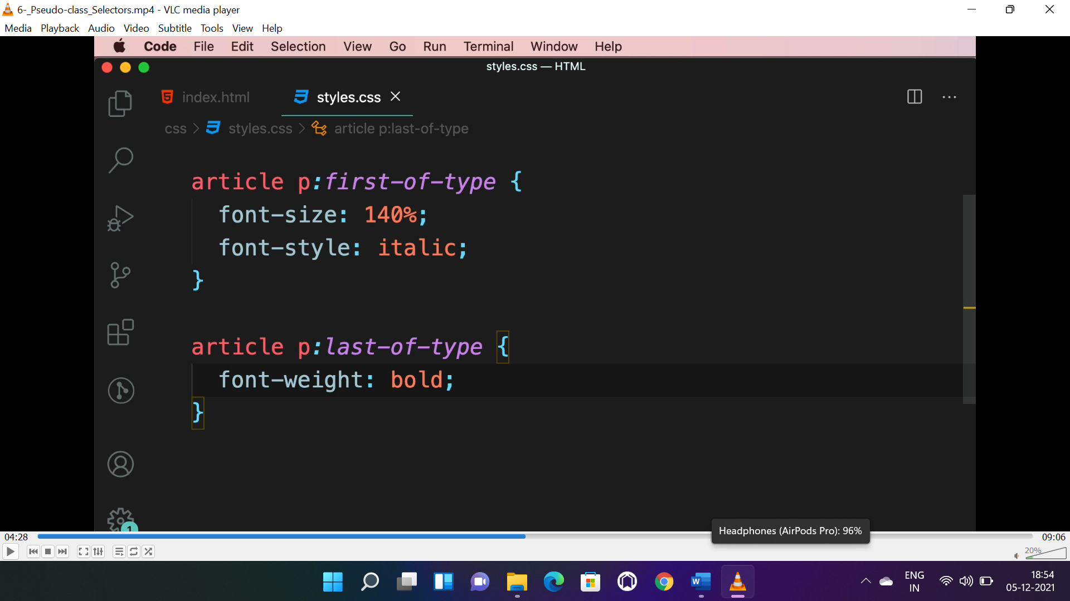

* It will apply to specific element and it is “<p>” here.

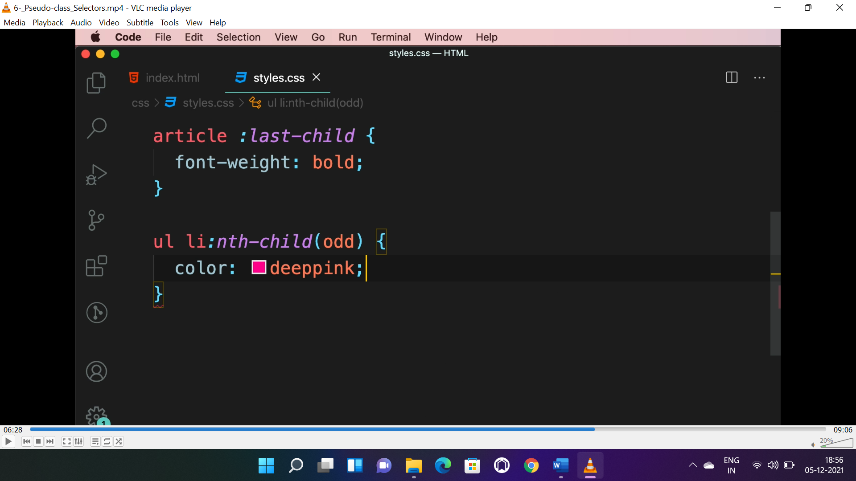 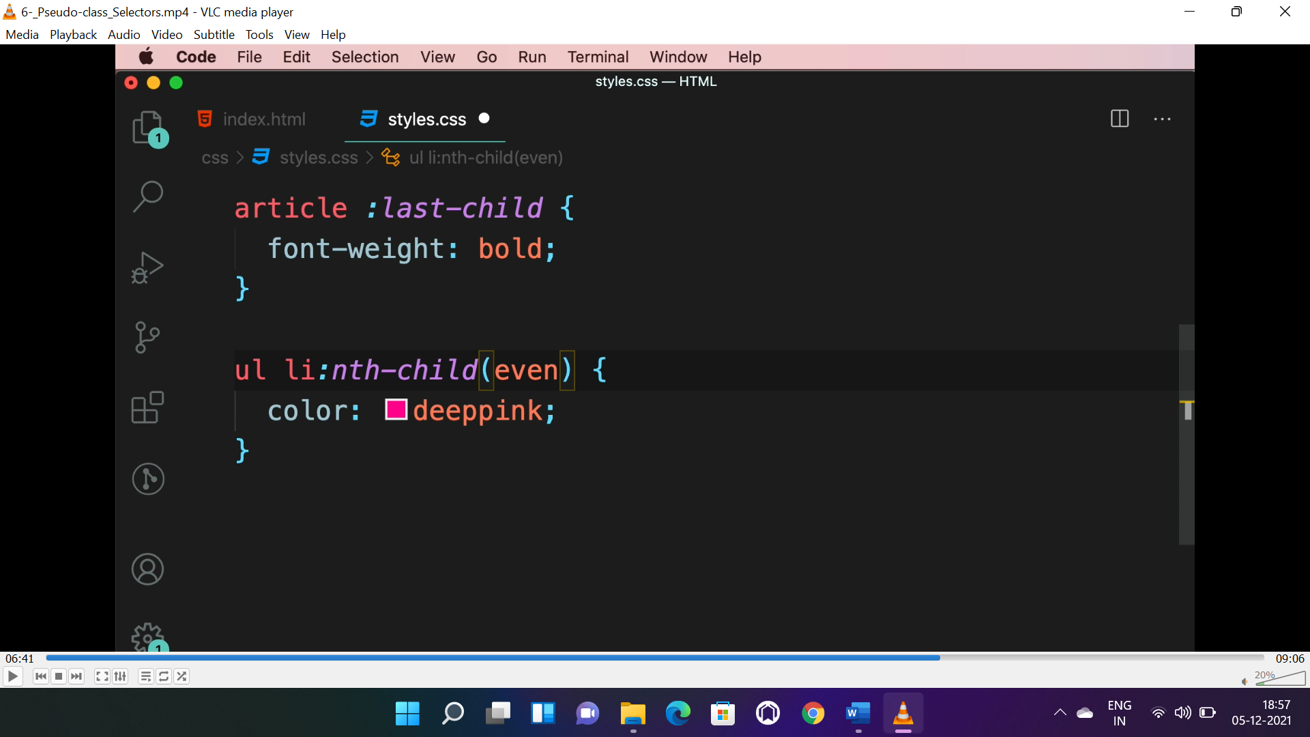 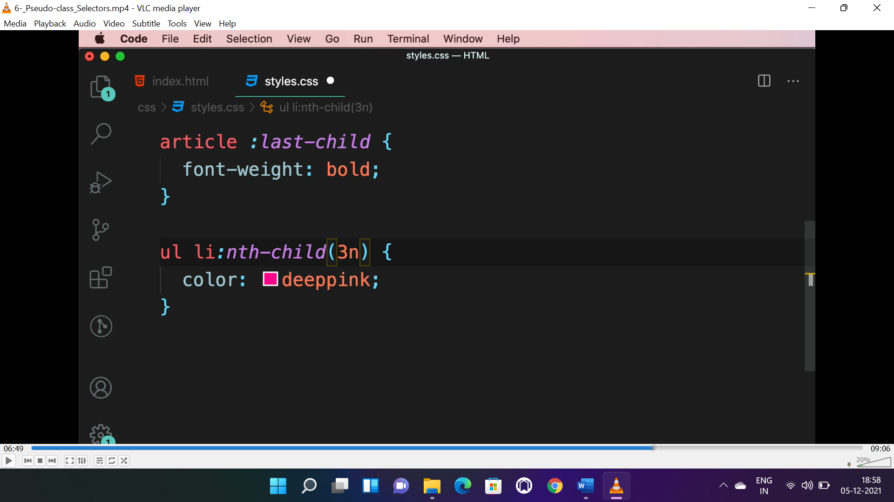

* Here “nth-child()” is a function, used to style particular element of “<li>” element here.

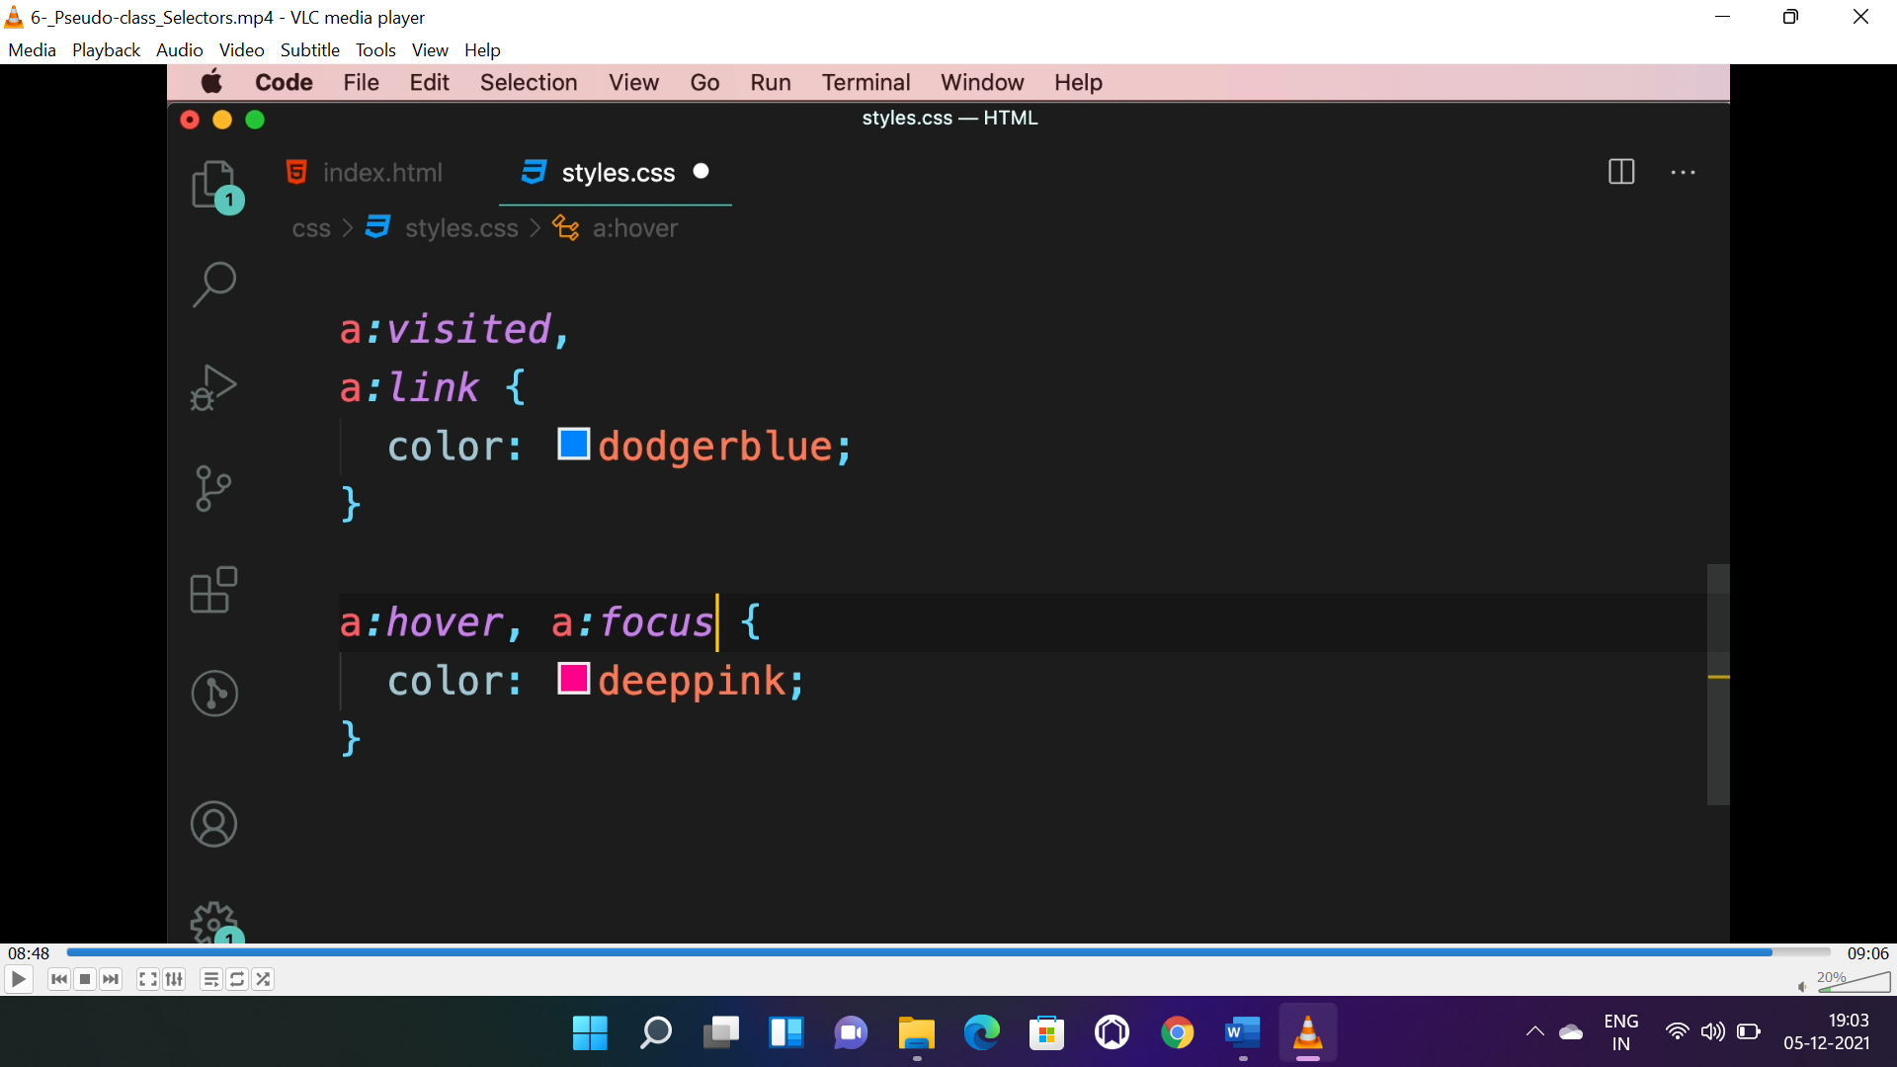

* To deal with “**hyperlink**” the above pseudo classes are used.

**SELECTOR SPECIFICITY:**

* !important> ID selector> class selector> element selector